Remembering the Heroes of Yesteryear ...
The Pacific Prowler is only one of a handful of B-25s that still flies today. The B-25 Mitchell Bomber was made famous on the daring Doolittle raid on Tokyo which took place four months after the Japanese bombed Pearl Harbor. The B-25 Bomber went on to become the most versatile medium bomber of World War II, seeing combat in every theater of operation.
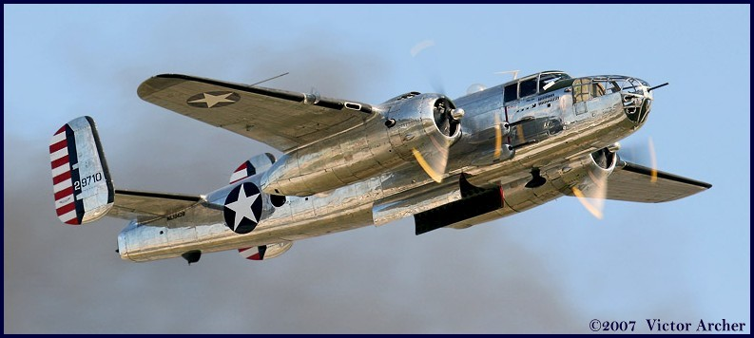
The Pacific Prowler is fully restored to her wartime configuration and ready to support your event. The uniqueness of the plane and our commitment to support your show set a new standard for air show exhibition. You’re not just booking our plane – you’re getting our assistance in marketing your event.
What we Offer… Incredible Visibility
- Before the show we will send information to pilots/aviation enthusiasts in your area advertising your event, as well as inviting them to take a ride with us. These lucky aviators will get an opportunity to ride in the B-25 and you get daily exposure of our magnificent plane flying over your city. Everyone in town will know that a very special air show is coming.
- Local media will be invited out to see the plane and share a flight with our crew. This means free TV, radio and newspaper coverage for your event!
- Daily flights before your show allow great air show advertising-in-action over your city.
- The plane will be parked per your designation in a highly visible position 3-5 days prior to your event. At a recent show our plane had over 120 people waiting in line to tour it, while just down the tarmac a newer military helicopter had about 15 people waiting. You can feel the history that the Pacific Prowler represents.
- The day before the show a special VIP flight for your crew and guests of your choice -- A perfect reward for your sponsors or staff’s hard work and effort!
- Our crew will be available for media interviews, luncheons, veterans groups and aircraft tours. We have an impressive presentation that will thrill your groups and honor our veterans with the history of the plane and the accomplishments of the men that flew her.
- During your show, we can provide high-speed passes with our bomb-bay doors open and closed while other warbirds attending your event provide top cover for the run. For a really speactatcular show, we'll work with your pyro people to add that extra special heart-pounding excitement to your event.

All of the above will be included in our exhibition package at no extra charge!

Pricing/Requirements...
Base Price -- $3,950.00 for a weekend event ($500 deposit to be paid upon contract signing; $3,450 due at end of event)
Fuel -- We require 100LL: 100 gallons (average) per flight during your event (show flights, VIP rides, etc.; exception - revenue rides for which we have only paying passengers onboard are done at OUR expense), plus top-off upon departure.
Oil -- Shell 120W or Phillips 25/60; 15 gallons for travel plus 2 gallons per flight during event.
Lodging -- We request three non-smoking, double hotel rooms.
Ground Transportation -- We prefer one minivan, mid-size SUV, or larger vehicle during our time onsite.
Insurance Information:
Airshow Liability Insurance in the amount of one million dollars is carried. A Proof of Insurance Certificate will be sent to the sponsor on request.

Brief Background:
The original Prowler was deployed to the Pacific theater and flew over 120 missions and returned home after the war. The Pacific Prowler II came out of storage in 1946 and served in the new US Air Force until 1958. She was bought by Tallmantz Aviation in 1962 and participated in over 80 Hollywood feature films including “Flight of the Phoenix”, “Catch 22”, “Around the World In 80 Days”, “Memphis Belle”, “For Whom the Bell Tolls” and the Disney 360 degree in the round videos. This aircraft has a rich history, qualified crew and impeccable maintenance. Just imagine what it was like taking off from the flight deck of a carrier in 1942!

Visitor Comments:
“Thank you so much, Dad had a stroke 10 years ago and this is the first time he has spoken since then.”

“This airplane was worth the price of admission.”

“Bless you for keeping this airplane flying.”

“Thank you for honoring them.”

“I needed to see this plane.”

“Amazing Condition.”

“My Dad was a tail gunner in this plane. He was killed and I never met him. This is the first time I’ve seen His plane.”

“I’ve got new respect for the men that flew now!”

“First time I’ve heard this plane run in over 60 years.”

“Thank you for keeping it flying.”

